Ideation Phase
Define the Problem Statements

Date | 07 August 2026
Name | DEEPAK C
Project Name | Shopez : E-commerce
Maximum Marks | 2 Marks

Customer Problem Statement Template:
Create a problem statement to understand your customer's point of view. The Customer Problem Statement template helps you focus on what matters to create experiences people will love.
A well-articulated customer problem statement allows you to find the ideal solution for the challenges your customers face. Throughout the process, you’ll also be able to empathize with your customers, which helps you better understand how they perceive your product or service
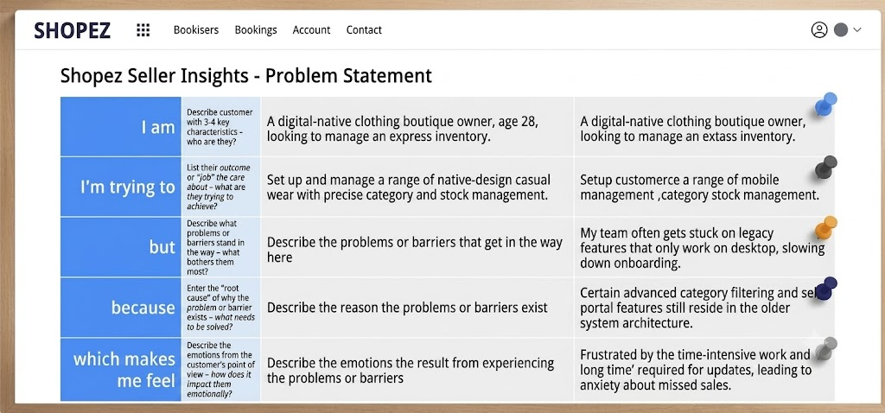
Example:
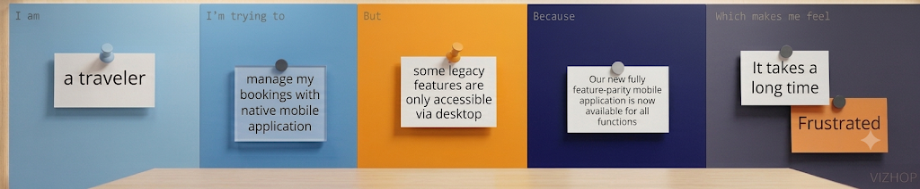
Problem Statement (PS) | I am (Customer) | I’m trying to | But | Because | Which makes me feel
PS-1 | A tech-savvy online shopper looking for quick daily tech deals | discover relevant discounts and compare curated product categories easily | I get overwhelmed by cluttered interfaces and hidden promo codes | e-commerce sites often have fragmented navigation, slow discovery, and buried offer codes | Frustrated and fatigued by wasted time
PS-2 | An independent seller / merchant looking to expand reach | set up my products and offer express deals directly to online shoppers | managing products and tracking promotion performance is overly complex | existing seller dashboards are bulky, hard to navigate, and lack clear onboarding | Disincentivized and anxious about lost sales

